WEEK-11
A) AIM: Write MongoDB queries to Create and drop databases and collections.

DESCRIPTION:
MongoDB is a NoSQL database that stores data in flexible, JSON-like documents.
Before working with documents, we must first create a database and collections within it.
A database is a container that holds multiple collections, and each collection stores documents (records).
MongoDB automatically creates a database or collection when you first insert data into it.
However, you can also create or drop them manually using specific commands.

PROGRAM:
1. Switch to a Database
use Student

2. Check Current Database

db
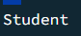
3. Create a Collection

db.createCollection("students")
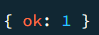
4. Show Collections

show collections


5. Drop a Collection

db.students.drop()

6. Drop the Current Database

db.dropDatabase()
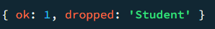

B) AIM: Write MongoDB queries to work with records using find(), limit(), sort(), createIndex(), aggregate().

DESCRIPTION:
MongoDB provides various query and data manipulation methods to efficiently handle records.
- find() — retrieves documents from a collection.
- limit() — restricts the number of documents returned.
- sort() — orders the result set.
- createIndex() — improves query performance by indexing fields.
- aggregate() — performs advanced data analysis using aggregation pipelines

PROGRAM:
1.create()

db.students.insertMany([
{ name: "Rahul", age: 20, department: "CSE", marks: 85 },
{ name: "Priya", age: 22, department: "ECE", marks: 78 },
{ name: "Amit", age: 21, department: "MECH", marks: 90 },
{ name: "Kiran", age: 23, department: "CSE", marks: 88 },
{ name: "Divya", age: 20, department: "EEE", marks: 75 }
])
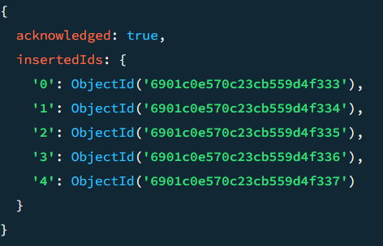

2.find()

db.students.find()

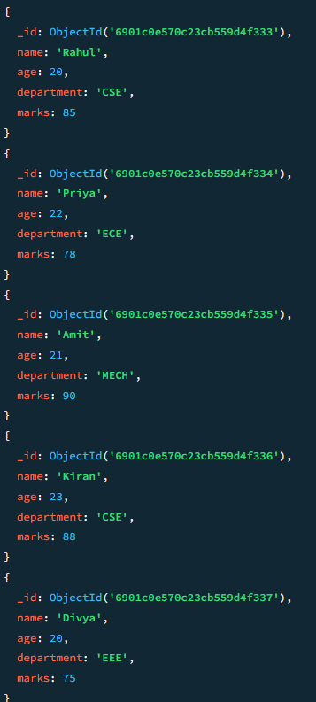

3.limit()
db.students.find().limit(3)

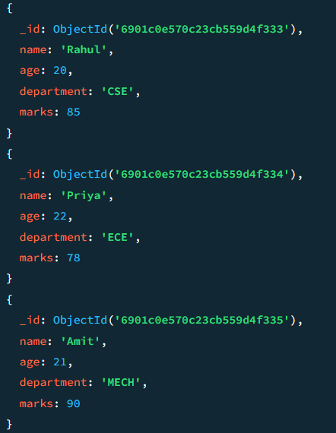

4.sort()

db.students.find().sort({ marks: 1 })

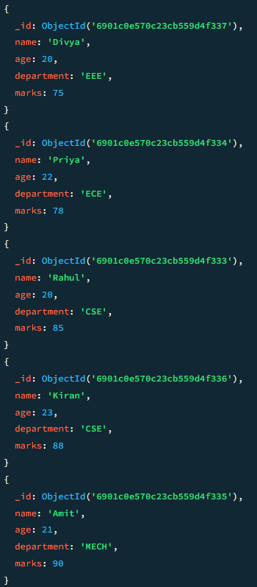

b) db.students.find().sort({ marks: -1 })

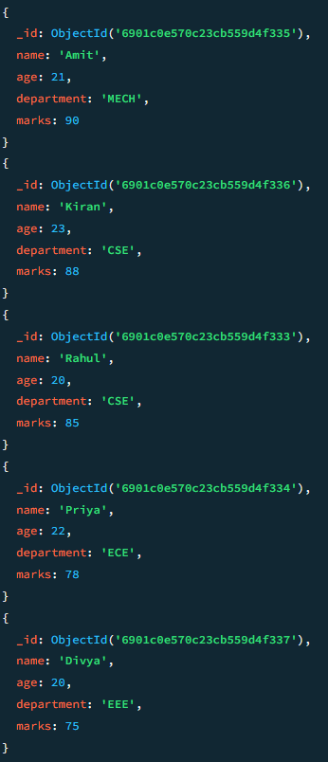

5.createIndex()

db.students.createIndex({ name: 1 })

6.aggregrate()

db.students.aggregate([
{ $group: { _id: "$department", avgMarks: { $avg: "$marks" } } }
])
